Cairo University Faculty of Computers and Information



**CS352 – Software Engineering II**

**Software design specification document**

**2018**

**Al italya Lebadat Al Bugs**

|  |  |  |  |
| --- | --- | --- | --- |
| **ID** | **Name** | **Email** | **Mobile** |
| 20150332 | Ahmed Amr Ali Al-Akwah | ahmeditalia122@gmail.com |  |
| 20150365 | Mohamed Fadl Al-Hdrmi | Hdrmim7@gmail.com |  |
| 20150321 | Noura AbdulKarim Mohammed | nouradel975@gmail.com |  |
| 20150331 | Hosam Eldeen Reda Abdulhady | hosamelkashab@yahoo.com |  |
|  |  |  |  |
|  |  |  |  |

**TA:Mohamed Samir**

Contents

Class diagram design 3

Sequence diagram design 5

Github repository link 5

# Class diagram designhttps://scontent-cai1-1.xx.fbcdn.net/v/t34.0-12/28722032_1685439534828208_685132113_n.jpg?oh=321f1ec47f98be446930932ff64bf888&oe=5AA19206

# Sequence diagram design:Buy product.

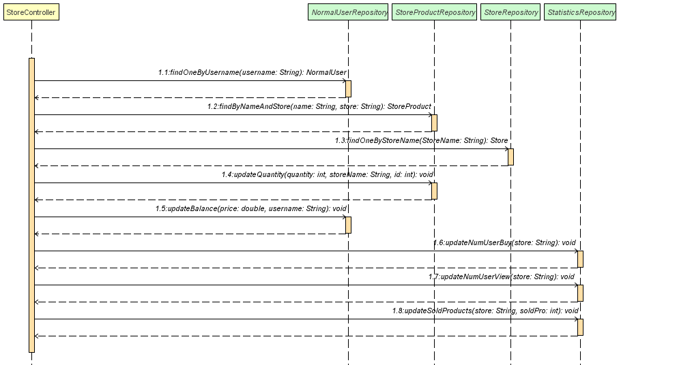

# Github repository link

**https://github.com/ahmeditalia/SWE2.git**